**Wenzhou-Kean University Group Assignment-3 Fall 2021**

**CPS 2390 W__ Computer Organization & Architecture   
Name: ________________________________ ID Number: ________________________________________**

**Name: ________________________________ ID Number: ________________________________________**

**Name: ________________________________ ID Number: ________________________________________**

# Problem 1 (1 Mark)

1. In this problem, your task is to design a finite state machine for a simple vending machine. Assume all the items are available for 15 cents and the machine can take in 5 cents or 10 cents as inputs. If at least 15 cents have been put into the machine, it’ll output the item selected but no change will be given back. Draw the state machine to model the behavior.

Hint: A state should represent how much money has been put in.

1. Draw the truth table and corresponding combinational logic for next states and output.
2. What changes will you make to the state diagram you made in previous question if you need to return change as well? Draw the updated state diagram.

Hint: Another output signal and state needs to be defined.

# Problem 2 (1 Mark)

Suppose a 32-bit instruction has a following format:

|  |  |  |  |  |
| --- | --- | --- | --- | --- |
| Opcode | DR | SR1 | SR2 | UNUSED |

If there are 225 opcodes and 120 registers,

* 1. What is the minimum number of bits required to represent the OPCODE?
  2. What is the minimum number of bits required to represent Destination reg?
  3. What is the maximum number of UNUSED bits in the encoding?

# Problem 3 (1 Mark)

Consider the following circuit:

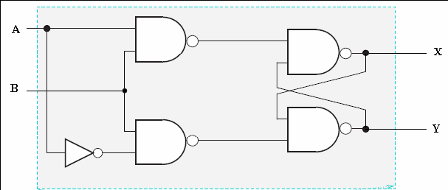

Assuming that initially X = 0 and Y = 1, show the waveforms for X and Y if the following inputs are applied:

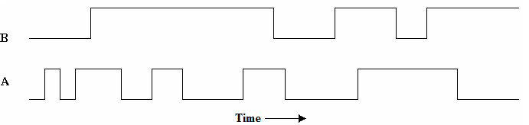

# Problem 4 (0.5 Mark)

Given a memory that is addressed by 22 bits and is 3-bit addressable, how many bits of storage does memory contain?

# Problem 5 (1.5 Mark)

The following table represents a small memory. Refer to this table for the following questions:

|  |  |
| --- | --- |
| **Address (16-bit binary)** | **Data (16-bit binary)** |
| 0000 0000 0000 0000 | 0001 1110 0100 0011 |
| 0000 0000 0000 0001 | 0101 1010 0110 0101 |
| 0000 0000 0000 0010 | 1111 1010 1100 1110 |
| 0000 0000 0000 0011 | 1111 1111 0011 0001 |
| 0000 0000 0000 0100 | 0000 0100 1100 1111 |
| 0000 0000 0000 0101 | 0101 0100 0110 1111 |
| 0000 0000 0000 0110 | 0000 0010 0001 1001 |
| 0000 0000 0000 0111 | 0000 0000 0000 0001 |

1. What hexadecimal value does address 0x2 contain? What about address 0x5?
2. Interpret value at address 0x3 as a 2's complement integer.
3. Interpret value at address 0x1 as an ASCII value.
4. Interpret value at address 0x4 as an unsigned integer.
5. In the von Neumann model, the contents of an entry in memory can be interpreted as an instruction. If the binary patterns in address 0x6 and address 0x0 were interpreted as a LC-3 instruction, what instructions would they represent?

Hint: Refer to appendix A.3 for complete instruction set of LC-3 (Page 525 of

*ltCS*).

1. A binary value can also be interpreted as a memory address. If the value stored in address 0x7 is a memory address, to what address does it refer? What binary value is stored in that memory address?